VMK JUNE 2020 MINISTRY REPORT

P.O.BOX 9277-00200: NAIROBI, KENYA
TEL: +254 202 047 117/+254 725 830 020
Email: -visionmnistrykenya@gmail.com
WEB: www.visionministrieskenya.org
Face book: Vision Ministries KENYA
DATE OF SUBMISSION: 24TH /JUNE/2020

INTRODUCTIONS
We know our partner churches and leaders from all regions in Kenya are generally in a tough position due to Covid-19.Life has become hard and hard indeed. We are having to reduce our life to merely having food, water and shelter, even so, these have become elusive due to financial challenges experienced currently. We are greatly inspired by most of our churches and church leaders that have continued to keep fire-burning despite the challenges. Even if it is ‘serving afraid’, the good news of Christ has to be preached to all the nations.
In the month of June Vision Ministry Kenya by the help of VMC donated some food to some of our members’ churches. This was a great encouragement to the leaders and the church as a whole. We sincerely acknowledge all the donors towards that worthy mission.
KAJIADO REGION JUNE 2020 REPORT
Leaders have continued reaching out to believers physically and via the phone calls. Alkesumet prayer center has been effective in organizing prayer sessions for the Kajiado VMK- leaders. In this month they were able to organize prayers for VMK pastoral leaders and youth leaders in the region. In the prayer meeting,Maasai bibles that were to be officially given to the Kajiado region leaders during the cancelled VMK-May Kajiado region Conference was formally handed over to them. The bibles were donated by Bible Society of Kenya organization, Kajiado West Sub-county office.
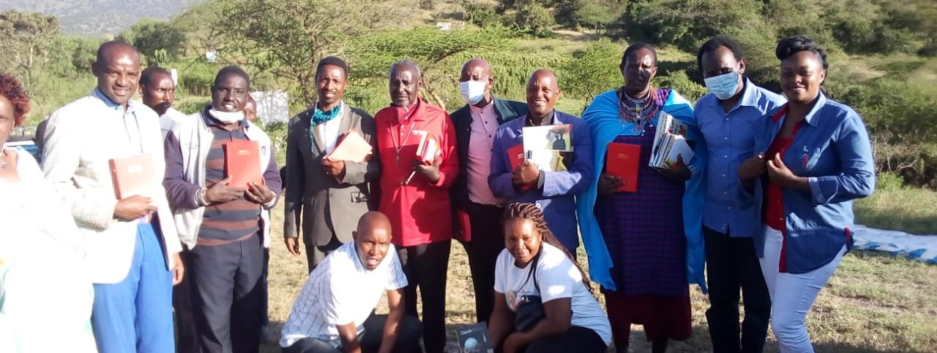VMK-Kajiado Region Prayer session held at Alkesumet Prayer Centre
Maasai Youth leaders at the prayer center
The Maasai leaders in Kajiado leaders are creating awareness to the believers about Corona-Virus pandemic. As they meet on the mountain for prayers, the leaders are encouraged to train believers of the safety measures to help contain the virus.
NAIROBI REGION JUNE 2020 REPORT
- Virtual Meeting
The Nairobi region for the first time succeeded in holding a zoom meeting. This however experienced several challenges.
The leaders generally highlighted activities they have been involved in at their church levels during the month of June. These included;
- Home cell fellowships
- Virtual sermons in Facebooks and church WhatsApp groups
- Phone call reach out to believers
- Church prayer meetings while observing containment protocols
- Food distribution to needy believers courtesy of VMC
- Television coverage preaching in a local TV station whenever possible
Hope Bible Chapel, Nairobi while in a prayer meeting
Pastor John Omeno in a local TV station preaching

- Sunday school Meetings and Fellowships
When today children and adolescents grow-up, will they see themselves as a “lost generation”, whose lives will forever fall in the shadow of a global pandemic? The church and school closures are one of the most visible- and controversial- means by which Covid-19 is affecting the children and the youth people in general.
According to UNESCO, the education of nearly 1.6 billion pupils in 190 countries has so far been affected – that’s 90 % of the world’s school age children. While the government of Kenya is s trying to encourage online church programs for the Sunday schools, it relies on good Tv or computer or android phones and reliable access to internet and source of power which are not very likely for most of our Sunday school children that are likely living in poverty and over-crowded households in Kenyan slums.
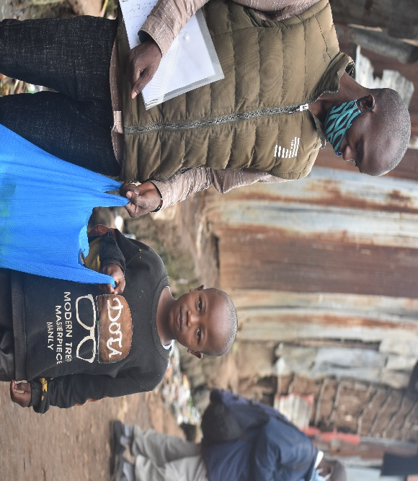
Vision Ministry Kenya is consulting with Nairobi churches to help come up with a simple program for children during this pandemic. It should be simple in the sense that any child can access it regardless of the background.
Hope Bible Chapel, deliver food to children during the pandemic courtesy of VMK
WESTERN REGION JUNE 2020 REPORT
Western Kenya number of covid-19 cases has escalated in the month of June. Fear has gripped most residence of this region especially those from Busia which is so far top five ranked county in Kenya that has recorded higher number of positive covid-19 infections.
Amidst the containment measures being implemented to suppress the escalating number of positive cases, the leaders have been working hard to ensure their believers are reached with the gospel of Christ.
The have been;
- Organizing house to house fellowships
- Having prayer meetings for leaders (about 5-10 leaders) while observing the set government rules and regulations.
- Holding one on one street evangelism. While doing this, one has to put on the mask and maintain social distance in compliance with the law.
NYANZA REGION JUNE 2020 REPORT
Home churches in Nyanza have been very effective during this period of the pandemic. Almost all our churches have been conducting revival meetings at the homes of the believers.
Prayer meetings have as well been intense. During this month there has been prayer and fasting meetings organized by pastors.
Evangelism – in reaching out to believers I’m told that fifteen souls were won to the kingdom in Mumbo and Kodera chapels in the first three weeks of the month of June. What a great encouragement and miracle to the kingdom of Christ.
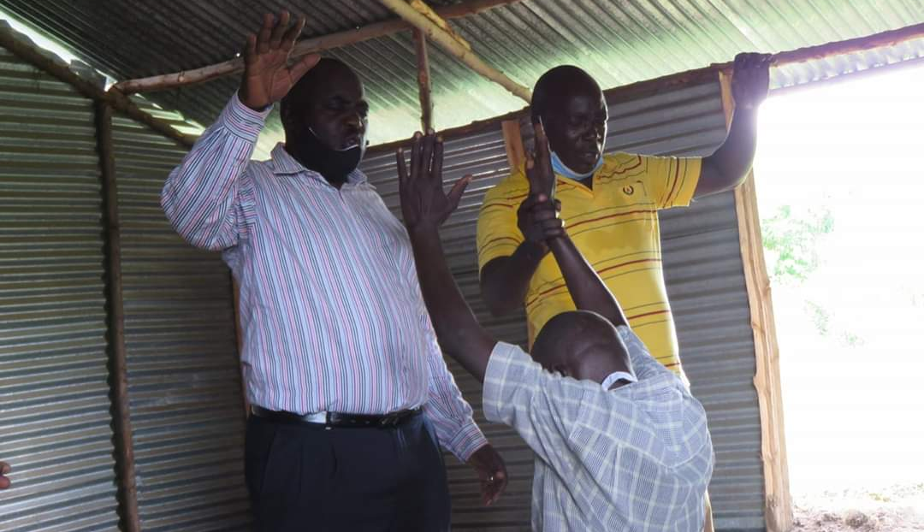Praying for a believer at mumbo chapel
Nyanza June Relief
Living in true fellowship with other believers requires a significant amount of self-sacrifice. In Acts, the fellowship of believers is described as “devoting themselves to the apostles’ teaching” and “selling their possessions and belongings and distributing to all, as any had need.” They met together, broke bread together, and had generous hearts (Acts 2). The picture of fellowship painted for us in Scripture is so much more than just eating a meal together; it’s sacrificing for one another. It’s not just doing life together; it’s laying down our lives together. It is behind this background that VMC donated food to help cushion believers during this hard time.
Brother Ishmael, sister Molline and Brother Fred were able to visit Nyora, Mumbo, Kodera and Homa-Bay chapels to distribute these food gifts. As they distributed food, they preached and prayed with believers.
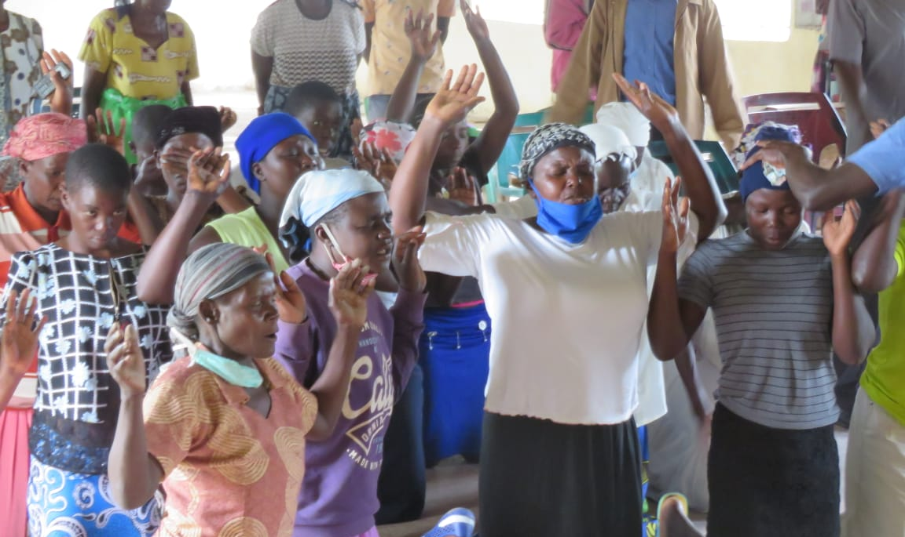Believers kneel for prayers after the preaching
Conclusion
As we continue serving our Lord Jesus during this pandemic, we appeal for prayers of brethren all over the world. We believe that through joint prayers the world will finally overcome this challenge.

